Interfaces Test 1

The menu at a lunch counter includes a variety of sandwiches, salads, and drinks. The menu also allows a customer to create a "trio," which consists of three menu items: a sandwich, a salad, and a drink. The price of the trio is the sum of the two highest-priced menu items in the trio; one item with the lowest price is free.

Each menu item has a name and a price. The four types of menu items are represented by the four classes

*Sandwich*, *Salad*, *Drink*, and *Trio*. All four classes implement the following *MenuItem* interface.

public interface MenuItem

{

/** @ return the name of the menu item */

String getName();

/** @ return the price of the menu item */  
 double getPrice();

}

The following diagram shows the relationship between the *MenuItem* interface and the *Sandwich*,

*Salad*, *Drink*, and *Trio* classes.

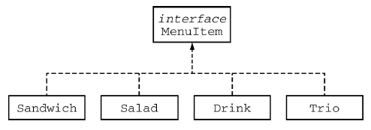

For example, assume that the menu includes the following items. The objects listed under each heading are instances of the class indicated by the heading.

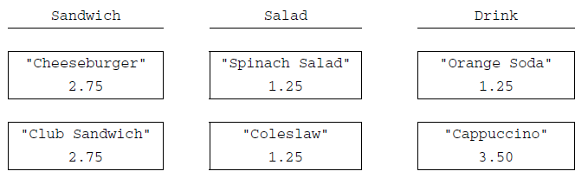

The menu allows customers to create *Trio* menu items, each of which includes a sandwich, a salad, and a drink. The name of the *Trio* consists of the names of the sandwich, salad, and drink, in that order, each

separated by "/" and followed by a space and then "Trio". The price of the *Trio* is the sum of the two

highest-priced items in the Trio; one item with the lowest price is free.

A trio consisting of a cheeseburger, spinach salad, and an orange soda would have the name

"Cheeseburger/Spinach Salad/Orange Soda Trio" and a price of $4.00 (the two highest prices

are $2.75 and $1.25). Similarly, a trio consisting of a club sandwich, coleslaw, and a cappuccino would have the

name "Club Sandwich/Coleslaw/Cappuccino Trio" and a price of $6.25 (the two highest prices

are $2.75 and $3.50).

Write the *Trio* class that implements the *MenuItem* interface. Your implementation must include a **constructor** that takes three parameters representing a sandwich, salad, and drink. The following code segment should have the indicated behavior.

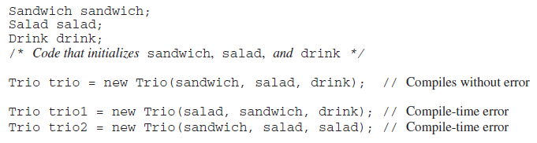

Write the complete Trio class below.